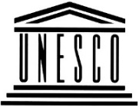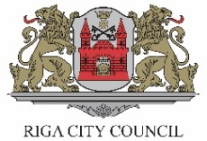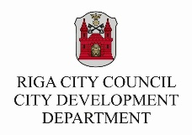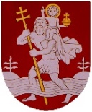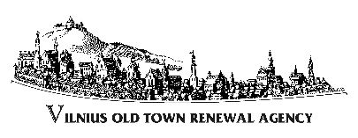

Project: Advancement of UNESCO World Heritage sites’ maintenance
in Vilnius, Riga and Tallinn
Kick-off meeting in Riga 09.-10.07.2020

PROGRAM

GUEST PARTICIPANTS AND 1-2 HOSTS’ REPRESENTATIVES
WEDNESDAY 8th of July
Arrival of guest participants and check-in (hotel Konventa sēta, Old Town)
- 16.15 Arrival of Vilnius team. International Bus Station (exhibition boards will be delivered to Townhall by small bus)
- Xx.yy Arrival of Tallinn team by car
~19.00 Walking tour in the Old Town to see what is new (restoration projects and new architecture)
20.00 - 21:30 Informal get together dinner (6-7 persons - guests and 1-2 representatives of hosts, location to be agreed on place)

ALL PARTICIPANTS
THURSDAY 9th of July

8.30-9.00 Registration & early coffee
9.00-9.20 Welcome of project partners:
- Hosts‘ official representative (welcome and few words about general state of the UNESCO WH site management affaires and preparation to the 25th anniversary celebration in 2022)
- Vilnius‘ representative (Program Manager) intro to the Program: common goals, performance and expected multipurpose outcomes
- Project partner greeting from Tallinn, preparation to the 25th anniversary celebration.
Overview presentations
9.20 - 10.00 Riga: maintenance, restoration and upgrade of the historic city centre in 1996-2020
10.00 - 10.40 Vilnius: maintenance, restoration and upgrade of the historic city centre in 1996-2020

10.40 - 11.00 Coffee break

11.00 - 11.40 Tallinn: maintenance, restoration and upgrade of the historic city centre in 1996-2020
11:40 – 12.00 Latvian National Cultural Heritage Board. Presentation on actual approach of cultural heritage protection, preservation, maintenance and development.
12.00 - 13.00 Comments from participants & first discussion

13.00 - 14.15 Lunch Restaurant Gutenbergs/Pētergailis/Ogle TBC

14.30 - 15.00 Opening of the exhibition „Preservation and maintenance of Vilnius Old Town 1994 – 2019“. Q&A to the media
15.00 - 15.30 Presentation: ~New architecture in Historic Centre of Riga (Artis Zvirgzdiņš, editor in chief, architecture platform A4D)
15.30 - 16.00 Presentations of relevant thematic brief case studies from Tallinn and Vilnius
16.00 - 16.10 Short coffee break
16.10 – 16.40 Presentation: ~Research and designing process of Medieval Riga Castle (research, functions, accessibility, informativity and attractivity, public avareness. Renovation of old railway storage building and creating of culture and events’ space Hanzas perons (Reinis Liepiņš, architect, Sudraba arhitektūra Ltd)
16.40 - 17.30 Thematic discussion

Walking tour in Historic Centre of Riga to see what is new (restoration projects and new architecture)

20.00-21.30 Official dinner (project partners and invited persons)
Venue: restaurant TBC

FRIDAY 10th of July

8.30-9.00 Early coffee
Local presentations on advanced projects, programs or activities:
9.00-9.30 Presentation: ~Quality restoration’s impact on urban environment. Masonry of St. Jacobs church and facades of some historic buildings (presentation by Arturs Lapiņš, architect AIG Ltd)
9.30 - 10.00 Presentation: Restoration Subsidies Program in Tallinn
10.00 – 10.30 Q&A and discussion
10.30 – 11.00 Presentation: Co-financing for the preservation of cultural monuments in Riga (presentation by Irina Miķelsone, Deputy head of Property Departament, Division for Arrangement of Buildings)
11.00 – 11.30 Special Riga case: ~City management and Citizens’ interests’ representation, rights and activities. Collaboration/engagement vs counteraction (A set of 1-2-3 short presentations from representatives of citizens’ and informal associations: Pilsēta cilvēkiem (City for people), Rīgas centra attīstības biedrība (Riga centre development society), Urban Institute, Free Riga …)

11.30 - 12.00: Discussion

12.00 - 12.20: Coffee break extended with snacks

12.20 - 13.00 Closing discussion on the Project meeting in Riga and preparations to the next meetings in Tallinn or Vilnius: goals, themes, outcomes. (Project teams’ participants only)

Noon: Departure of guest participants
15.00 Lithuanian participants leaving Riga by bus from International Bus Station.

Optional: Complementary program (all interested participants)
13:00: Visiting museum “Rīgas jūgendstila centrs” to get acquainted with maintenance and preservation and popularization of Art Nouveau heritage by looking at the interior of an Art Nouveau apartment, as well as a modern and interactive digital exposition. Guidance in ENG/LV http://www.jugendstils.riga.lv/eng/
(meeting at 12:55, entrance Alberta street 12)

