
Oslo kommune
Byantikvaren
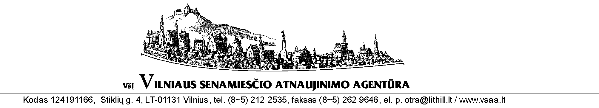

(DRAFT)

Suggestions from the delegation from Oslo City’s Cultural Heritage Management
and Vilnius Old Town Renewal Agency
on Vilnius’ Wooden Architectural Heritage Preservation Action Plan

Strategic use of municipal grants
Continue current practice of Vilnius Old Town Regeneration Program’s sub-program “Community Capacity Building” by strictly ensuring the condition of having a direct owner’s involvement, economic participation and responsibility for consequent maintenance of the historic property. To not provide municipal granting under the sub-program unless it’s guaranteed that the total result will be best practice, e.g: use of traditional building materials and relevant methodology of restoration, ensure safeguard and conservation of authentic windows, doors, panelling, decoration, colours etc.

Promotion and Public Information
More actively use the media to spread consumer information about architectural and urban value of wooden houses, the need to share knowledge and experience on relevant maintenance and use of the wooden historic houses, and marked value in other countries.

Develop specialised guidelines and internet information about relevant wooden house maintenance, repair, restoration, insulation, adoption to new uses, etc. A good start could be the translation and adaption of some of the Norwegian material in use.

Fund the acquisition or long term lease of one of the most valuable historic wooden houses in Zverynas or Snipiskes district. Restore the house according to best practise engaging the best local experts and craftsmen. Make the restoration project an open process with learning for craftsmen, the public and the press. After and during the restoration the house should function as an information centre and/ or community centre for use of proper promotion of qualified restoration of the wooden houses. The project should get EEA and/or semi-private funding, also considering the need to get seed money support from the municipal budget.
Give Zverynas and Snipiskes its colour back
These Vilnius’ districts still possess a very valuable and authentic houses that are to a large degree in serious lack of maintenance or disrepair. To turn the spirit of depression it would already help to clean and paint the facades of efficient number of wooden houses in both districts. By giving out linen seed oil paint of the traditional local colours the face and image of the districts could be changed for a relatively small amount, but positive dynamics for the revival would be stimulated. Paint should be distributed and a team of the restoration and paint experts should help the owners with the preparation and painting process. The campaign would attract media interest and could be financed by private businesses.

Save a roof
Ensure municipal, sponsors and/ or semi-private funding for a fixed grant per roof as a contribution for replacing or fixing leaking roofs of valuable wooden houses. Simple application procedure should be based on owners’ will and ability to share the costs of work and take consequent responsibility of its maintenance. Preferably to be performed prior to the paint project or at least follow-up of it.

Revolving funds
Get funding for going into the most valuable houses with difficult owner conditions, acquire the property, develop it rationally and according to best practice. Then sell the house in the market. The money, hopefully with a profit, can then be reinvested in a new house.

Independent NGO
To voice the preservation needs and interests for the wooden architecture of Vilnius. The consolidation of public, municipal, city districts’, local communities’ and private interests in historic properties’ preservation needs to be integrally targeted. To ensure regular work based on the PPP principles, and aimed to make possible for owners to develop their properties in a way that respects the heritage as well as area urban values, the specialised non-government organisation needs to be found. Until the specialised organisation would be set, Vilnius Old Town Renewal Agency (OTRA) could commence this work.

Monitoring and impact assessment
Vilnius OTRA would regularly induce and supervise the process, actively communicating/ cooperating with Vilnius municipal administration, district authorities, communities and property owners. OTRA would regularly report municipal authorities about the obstacles, needs and progress of the wooden heritage regeneration process, and would develop proposals for improvement of the wooden architectural heritage regeneration in Vilnius.

M. Stige, 03.11.2009
G. Rutkauskas, 24.11.2011

