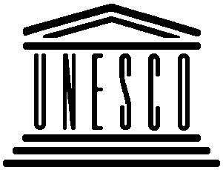 | United Nations Educational, Scientific and Cultural Organization  Organisation des Nations Unies pour l‘éducation, la science et la culture  Centre du patrimoine mondial  World Heritage Centre | 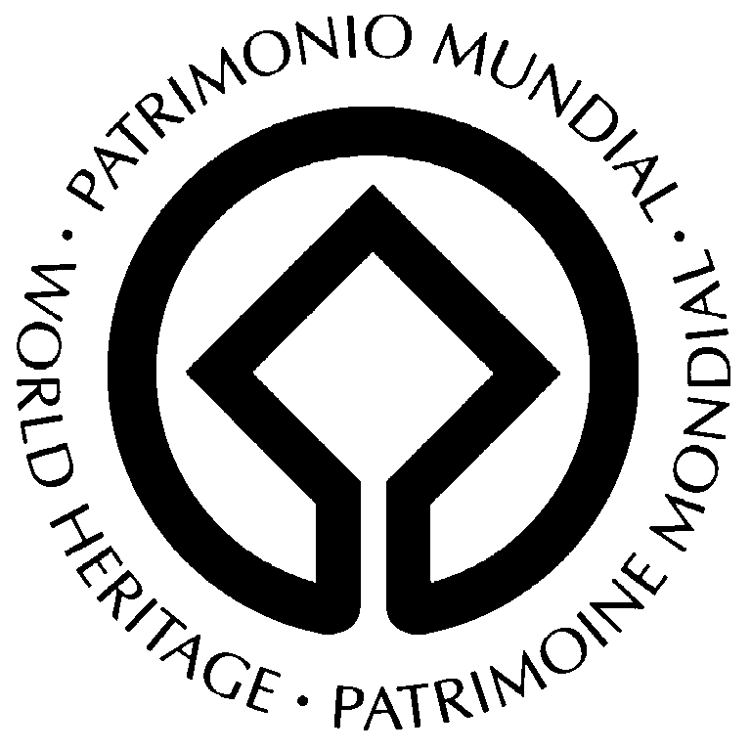
7-8 DECEMBER 2006, VILNIUS, LITHUANIA

CONCLUSIONS OF VILNIUS REGIONAL SEMINAR
“HIGH-RISE BUILDINGS AND HISTORIC CITY CENTRE”

Theme I “Importance and competitiveness of new development”

Statement: For the three Baltic States with their economies in transition, the current boom in investment and development in the three World Heritage Cities of Tallinn, Riga and Vilnius should be welcomed and utilized, in the most sensible and sensitive way, in order to generate funds for conservation – not to jeopardize or to destroy the Outstanding Universal Value for which they were inscribed on the World Heritage List of UNESCO.
Recommendation: To determine appropriate locations, types and forms of development in and around the WH cities, thorough analysis and studies have to be conducted, including economic feasibility studies into the necessity of high-rise constructions with full cost-analyses.

Theme II “Preservation and continuity of urban landscape”

Statement: While mistakes have been made in the past in all three World Heritage Cities, which have left high-rise buildings in various locations infringing on the visual integrity of the sites, there is a growing awareness of the significance and importance of the historic urban landscape as a character-defining element underpinning the Outstanding Universal Value.
Recommendation: To utilize viewpoint-, silhouette- and urban morphology analyses to supplement historic townscape descriptions, to assess visual impacts on the WH cities and to guide city planning upstream of development proposals –not after planning decisions have already been made– and to inform the WH Committee of these analyses with related decisions.

Theme III “Community involvement in city planning process”

Statement: While community involvement is pursued by local and national authorities, this is currently more a formality than a genuine attempt to generate input from civil society to inform decision making.
Recommendation: Improve transparency of processes and information provision to citizens, and WH Committee, in order to build wider consensus and reduce polarization, and to create a sense of ownership among all stakeholders, which is still one of the best guarantees for the long-term conservation of World Heritage cities.

