THE EUROPEAN ARTISTIC CRAFTS DAYS „LET’S SHAPE THE FUTURE“

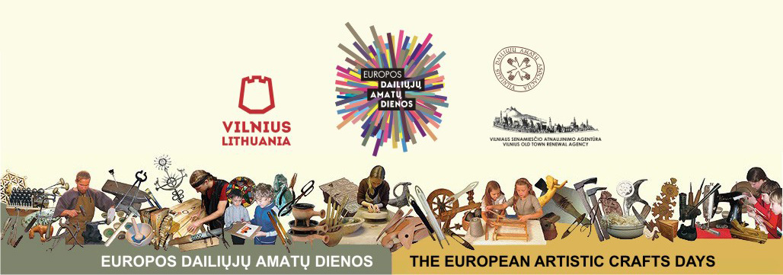
April 1-3, 2016

PROGRAMME

EXHIBITIONS
On April 1-3, 2016

Baroque clocks made by old master Jokubas Gierke
Exposition of historical jewelry of 15-17 th c.
Jeweller Darijus Gerlikas, Darijaus gallery, Dominikonų St. 7/20
Working hours: 12.00-18.00, on April 1-2

Exhibition „Quilts of Adele“
Artisan Adelė Meškauskaitė-Račkauskienė
The Old Crafts‘ Workshops, Saviciaus St. 10
Working hours: 11.00–19.00, on March 18 – April 18

Watercolours and black ceramics „Art – living history”
Artisans: Anatolijus Sčiogolevas, Eglė Paukštienė ir Eugenijus Paukštė
Black Ceramics Gallery and Workshop „ Molio laumė“, Naugarduko St. 20
Working hours: 14.00–18.00, on April 1- May 1

Exposition of amber music instruments
Museum of Amber sculptures „Amber“, Aušros vartų St. 9
Working hours: 10.00–17.00, on April 1 - 3

Exhibition of ideas „Textile versus Jewelry“
Artists – students of Vilnius Academy of Arts
Weave Manufactory „Jūratė“, Didžioji St./Savičiaus 20/1
Working hours: 10.00-19.00, April 1st

SPECIAL EVENTS (SHOWS, WORKSHOPS, LECTURES)

Time | Name of event / name of craftsman | Name and address of a place
April 1st
9.30-12.30 | Presentation of the origin of amber and the show of ancient processing of amber. | Art Center of Baltic Amber  Šv. Mykolo St. 12  www.ambergallery.lt
11.00-13.00 | Show and workshop of leather works for shcool children (making leather bracelets, etc.)  Artisan Liucija Petkevičienė | The Centre of Crafts and Arts "Nauja sirena"  Mėsinių St. 9,  www.sirena.lt
11.00-13.30 | Show of leather craft – ways of decoration with ornament  Artisan Martynas Švedas | The Old Crafts‘ Workshops  Savičiaus St. 10,  www.seniejiamatai.lt
12.00-16.00 | Show of making ceramics  Artisan Vygantas Vasaitis | Ceramics workshop „Amatu gildija“, Skapo St. 3  www.amatugildija. Lt
13.00-15.00 | Lecture „Gothic ferment ceramics“ and the workshop  Artisan Dainius Strazdas | Workshop of Vilnius Potters  Uzupio St. 9/2
14.00-16.00 | Drawing of portraits using silhouette technique  Artisan Edita Namajūnienė | The Old Crafts‘ Workshops  Savičiaus St. 10,  www.seniejiamatai.lt
15.00-17.00 | Show of ferment pottery process in the yard of Uzupis Art Incubator  Artisan Dainius Strazdas | Workshop of Vilnius Potters  Užupio St. 2
16.00-18.00 | Lecture „The historical bookbinding structure during 1st–16th centuries“, the show of a art and the presentation of bookbinders workshop.  Artisans Rimas Supranavičius ir Sigitas Tamulis | The Old Crafts‘ Workshops  Savičiaus St. 10,  www.seniejiamatai.lt
17.00-19.00 | Presentation of black ceramics craft and practical workshop  Artisan Eugenijus Paukštė. | Black Ceramics Gallery and Workshop “Molio laumė”  Naugarduko St. 20,  www.ceramics.w3.lt
17.30-19.30 | Presentation of smithery craft and its historical development. Lithuanian cross-crafting tradition: making the „Sun“  Artisan Raimondas Vaitkūnas | Smithery Museum,  Užupio St. 26  www.vilniauskalviai.lt
April 2nd
9.30-12.30 | Presentation of the origin of amber and the show of ancient processing of amber. | Art Center of Baltic Amber  Šv. Mykolo St. 12
10:00-11:30 | Show and workshop of cutting paper: Eastern eggs‘ decorations and postcards.  Artisan Klaidas Navickas | The Workshop-salon of folk  artist Klaidas Navickas  J. Basanavičiaus St. 29,  www. klaidaspapercuts.lt
12:00-13:30 | Show and workshop of cutting paper : Eastern eggs‘ decorations and postcards.  Artisan Klaidas Navickas | The Workshop-salon of folk  artist Klaidas Navickas  J. Basanavičiaus St. 29,  www. klaidaspapercuts.lt
12.00-14.00 | Show of a bookbinding art of Renaissance period  Artisan Sigitas Tamulis | The Old Crafts‘ Workshops  Savičiaus St. 10,  www.seniejiamatai.lt
12.00-16.00 | Show of the linen textile craft for schoolchildren "Linen Road"  Artisan Gražina Kuzmickienė | Weave Manufactory "Jurate"  Didžioji St./Savičiaus St. 20/1,  www.jurate.eu
13.00-17.00 | Enamel traditions and technologines in Lithuania. Workshop for families (for 2–3 generations) of enamel art. Each family will create one peace of work.  Artisan Marytė Dominaitė-Gurevičienė | Goldsmith Guild "Meno niša"  J. Basanavičiaus St. 1,  www.menonisa.lt
14:00-15:30 | Show and workshop of cutting paper : Eastern eggs‘ decorations and postcards.  Artisan Klaidas Navickas | The Workshop-salon of folk  artist Klaidas Navickas  J. Basanavičiaus St. 29,  www. klaidaspapercuts.lt
14.00-15.00 | Show of making glass beadings  Artisan Daiva Jusiūtė-Tarailienė | The Old Crafts‘ Workshops  Savičiaus St. 10,  www.seniejiamatai.lt
15.00-16.00 | Show of the new technologies of quilts‘ craft: using the melting paper  Artisan Gražina Kriaunevičienė | The Old Crafts‘ Workshops  Savičiaus St. 10,  www.seniejiamatai.lt
17.30-19.00 | Presentation of smithery craft and its historical development. Lithuanian cross-crafting tradition: making the „Sun“  Artisan Raimondas Vaitkūnas | Smithery Museum  Užupio St. 26  www.vilniauskalviai.lt
April 3rd
9.30-12.30 | Presentation of the origin of amber and the show of ancient processing of amber. | Art Center of Baltic Amber (amber art)  Šv. Mykolo St. 12
10:00-11:30 | Eastern eggs‘ decorations with wax.  Artisan Gitana Navickienė. | The Workshop-salon of folk  artist Klaidas Navickas  J. Basanavičiaus St. 29,  www. klaidaspapercuts.lt
12:00-13:30 | Eastern eggs‘ decorations with wax.  Artisan Gitana Navickienė. | The Workshop-salon of folk  artist Klaidas Navickas  J. Basanavičiaus St. 29,  www. klaidaspapercuts.lt
12.00-13.00 | Show of the new technologies of quilts‘ craft: quick sewing technique  Artisan Gražina Kriaunevičienė | The Old Crafts‘ Workshops  Savičiaus St. 10,  www.seniejiamatai.lt
13.00-14.00 | Show of making glass beadings  Artisan Daiva Jusiūtė-Tarailienė | The Old Crafts‘ Workshops  Savičiaus St. 10,  www.seniejiamatai.lt
14:00-15:30 | Short films about cutting paper and shadows‘ theatre.  Artisan Klaidas Navickas. | The Workshop-salon of folk  artist Klaidas Navickas  J. Basanavičiaus St. 29,  www. klaidaspapercuts.lt
17.30-19.00 | Presentation of smithery craft and its historical development. Lithuanian cross-crafting tradition: making the „Sun“  Artisan Raimondas Vaitkūnas | Smithery Museum  Užupio St. 26  www.vilniauskalviai.lt

