“Safeguard of Wooden Architectural Heritage in Vilnius”
The Project developed by Vilnius OTRA and Vilnius municipal Unit for Cultural Heritage
in cooperation with Oslo municipal Cultural Heritage Management Office

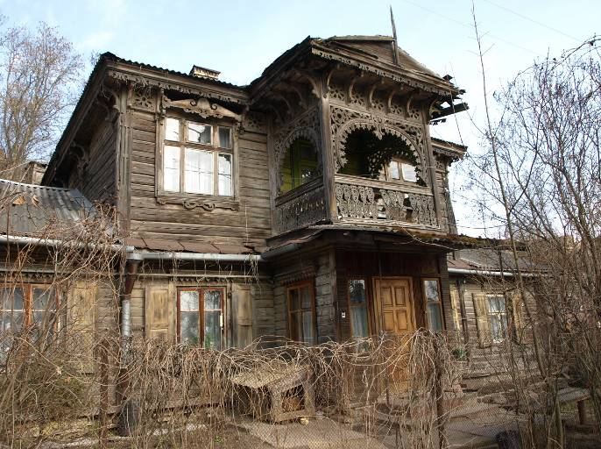

The First Seminar of the Project, 2009/ 10/ 29-30, Vilnius
PROGRAM OF THE SEMINAR

2009/ 10/ 29, THURSDAY
(Vilnius Old Town Renewal Agency, Stikliu st. 4, Vilnius)

10.00 – 12.00 Preservation of the Wooden Architecture in Norway and Oslo

10.00 – 10.15 Welcome and introduction of Seminar participants:
- Deputy Mayor of Vilnius city Mr. Stanislovas Šriūbėnas,
- Head of Vilnius municipal Unit for Cultural Heritage Mr. Vitas Karčiauskas,
- Initiator of Vilnius-Oslo agreement in 1991, M.Sc. of architecture Mr. Aage Myhre,
10.15 - 10.45 – Presentations of the Guests/ experts from Oslo city:
- From medieval lofts to post war villas. A brief presentation of the higlights of our wooden heritage and the tradition to build with wood, Mr. Truls Aslaksby,
- Oslo’s wooden heritage. An overview with emphasis on the wooden suburbs from the late 19th. Century. Case study of Rodeløkka or Kampen, Ms. Brit Kyrjebo,
10.45 - 11.00 Coffee brake,
11.00 - 12.00 – Thematic presentations „Management and tools in the preservation work“ :
- The challenges: Surplus/poverty, Speculation, Craftsmanship, Fire,
- Historical development of appreciation of wooden suburbs in Norway. From sanitation to protection,
- The Urban renewal project in Oslo in the 1980’ies,
- Norwegian legal framework for protection Mr. Morten Stige, Head of the Office,
- Grants. Financing and conditions,
- Craftsmanship and materials, Information strategies, Mr. André Korsaksel,
12.00 – 13.30 Lunch,
13.45 - 14.15 Visit to Žvėrynas district ( historic 19th. C. suburb of Vilnius,
- welcome by Head of Žvėrynas Local Administration Mr. Tautvydas Klimavičius,
- introduction of the exhibition “Wooden Architecture in Žvėrynas”,
14.15 – 16.00 – site seeing in Žvėrynas, visit of the recently upgraded/ restored wooden houses and meetings with the property owners;
16.00 – 17.00 – round table discussion in Žvėrynas Local administration office with attendance of
Žvėrynas community leaders and historic property owners.

2009/ 10/ 30, FRIDAY
(Vilnius Old Town Renewal Agency, Stiklius t. 4, Vilnius)

10.00 – 12.00 Preservation of Wooden Architecture in Vilnius

10.00 – 10.05 Introduction and reflections from the first day of the Seminar;
10.05 - 10.25 Undertakings and plans of Vilnius municipality, Mr. Vitas Karčiauskas,
10.25 – 10.45 Practical experience of Wooden Heritage Preservation Management and Treatment in Vilnius: community awareness rising and engagement, physical renovation of historic properties, Mr. Gediminas Rutkauskas, Director of Vilnius OTRA, (www.vsaa.lt)
11.00 – 11.15 Coffee brake,
11.00 - 12.00 Presentations of the experts from Vilnius city:
- Preservation of Wooden Architecture by the researcher’s eye, Mrs. Dalė Puodžiukienė, restoration architect-researcher,
- Contradictory Fate of Žvėrynas’ Wooden Architecture, Mr. Vytautas Damaševičius, member of Žvėrynas community
12.00 – 13.20 Lunch,
13.30 – 16.30 Visit to the protected areas of the wooden architecture Šnipiškės, Antakalnis,
Naujininkai, Markučiai.
16.30 – 17.30 Concluding discussion: summary from the presentations and discussions,
development of issues to be targeted at the next Project Seminar in Nov. 19-20 in Olso.
(Vilnius Old Town Renewal Agency, Stikliu st. 4)
19.00 Cultural event for the participants of the Seminar (to be specified).

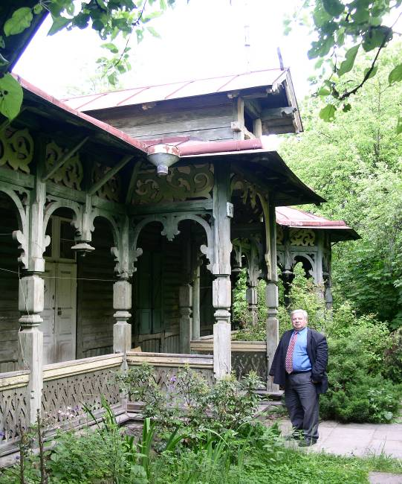

Project „Preservation of traditional wooden architecture of Vilnius City”

Vilnius Old Town Renewal Agency prapared a project „Preservation of traditional wooden architecture of Vilnius City” in 2009, and have got a partial financial support of 10 000 LTL for the project from Lithuanian Cultural Support Fund. Project partners are Cultural Heritage Management of the City of Oslo (Byantikvaren) and Cultural Heritage Division of Urban Development Department of the City of Vilnius.

Goal of the project is quality improvement of wooden architectural heritage management, with the help of exchange of experience of management specialists in order to improve their knowledge and professional self-awareness. The analysis and discussions will be enriched with the help of practitioners, owners and users of historical properties: leaders of local wards and communities, activists and volunteers of the field.

It is planned to organize two seminars: one in Vilnius and one in Oslo. Delegation of Cultural Heritage Management of the City of Oslo (4 persons including the Head of the Department) will visit Vilnius on 28-30th of October. Meetings with specialists of Cultural Heritage Division of the City of Vilnius, owners of protected wooden architectural heritage buildings, and representatives of local communities and Žvėrynas district ward will take place. Renovated or planned for renewal buildings will be visited, tools, means and consequences of management and restoration works will be analyzed. Group of Vilnius specialists will visit Oslo on 19-21th of November. An experience of Norwegian colleagues will be discussed, analyzed and compared with the practice and results of the management of Vilnius cultural heritage. During the discussion of the challenges of preserving the wooden heritage, tools for its preservation and management, the action plan will be created. The management of preservation of wooden architectural heritage will be improved with the help of the plan.

It is planned to prepare and issue a special publication, which will present the clear information for owners and users of historical wooden architectural heritage buildings regarding proper and sustainable maintenance of wooden buildings. The content of the publication will be contained into internet pages of Vilnius City Municipality and Vilnius Old Town Renewal Agency. The project aims to create “Plan of actions and means of Vilnius wooden architectural heritage preservation” which will be presented for Vilnius City Municipality.

